AVIP-DE-DAN
Dante 2CH Analog Audio Decoder with POE
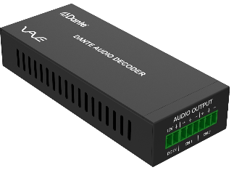
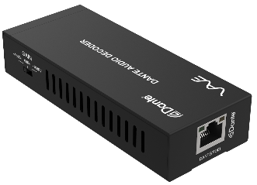
FEATURE:

- Analog audio output supports balanced/unbalanced audio output (unbalanced access to "+" and "GND")
- Audio sampling rate supports 44.1kHz, 48kHz and 96kHz (24bit)
- Dante solution supports AES67 RTP audio transmission
- Audio output supports 3-level gain adjustment：+18dBu, 0dBu (default) and -10dBV
- Support DC 12V power supply and POE function (IEEE802.3af Class 0)

AVIP-DE-DAN
This Dante 2CH Analog Audio Decoder is an audio receiver that utilizes the Dante Ultimo solution. It offers both balanced and unbalanced audio output, along with a 3-level gain adjustment feature. The device receives audio signals from the transmitting end over a Dante network, decodes the signals, and outputs them as analog audio. Additionally, it supports Power over Ethernet (POE) functionality.



Audio

Dante 2CH Analog Audio Decoder with POE

Dante 2CH Analog Audio/ Decoder with POE
AVIP-DE-DAN

SPECIFICATIONS:
Technical
Video Network Bandwidth | 100M
Audio Formats | PCM 2.0 44.1kHz/48kHz/96kHz up to 24bit
Transmission Distance | 100m (CAT6/6A)
Control Method | Dante Controller
Connection
Input | 1x DANTE [RJ45 connector, POE]
Input | 1x PWR [2-pin phoenix, 3.81mm]
Output | 1x AUD [6-pin phoenix, 3.81mm]
Mechanical
Housing | Metal Enclosure
Color | Black
Dimensions | 120mm[W] x 47mm[D] x 26mm[H]
Weight | 186g
Power Supply | DC input: 12V
Power Supply | POE input: IEEE802.3af Class 0
Power Consumption | 1.32W
Operation Temperature | 32 - 104ºF / 0 - 40ºC
Storage temperature | -4 - 140ºF / -20 - 60ºC
Relative Humidity | 20 - 90% RH (no condensation)

www.vave-av.com
Audio

